HR SCORECARE

1. Introduction:

Overview:

It is the mission of the human resources department to provide the following quality services to the employees of [Company Name]: Recruitment of qualified individuals. Retention of valuable employees. Training, development and education to promote individual success and increase overall value to the organization.

Purpose:

It is the mission of the human resources department to develop, implement and support programs and processes that add value to [Company Name] and its employees, leading to improved employee welfare, empowerment, growth and retention, while remaining committed to [Company Name]'s key business drivers, its management

1. Problem Definition & Design Thinking:

Empathy Map:

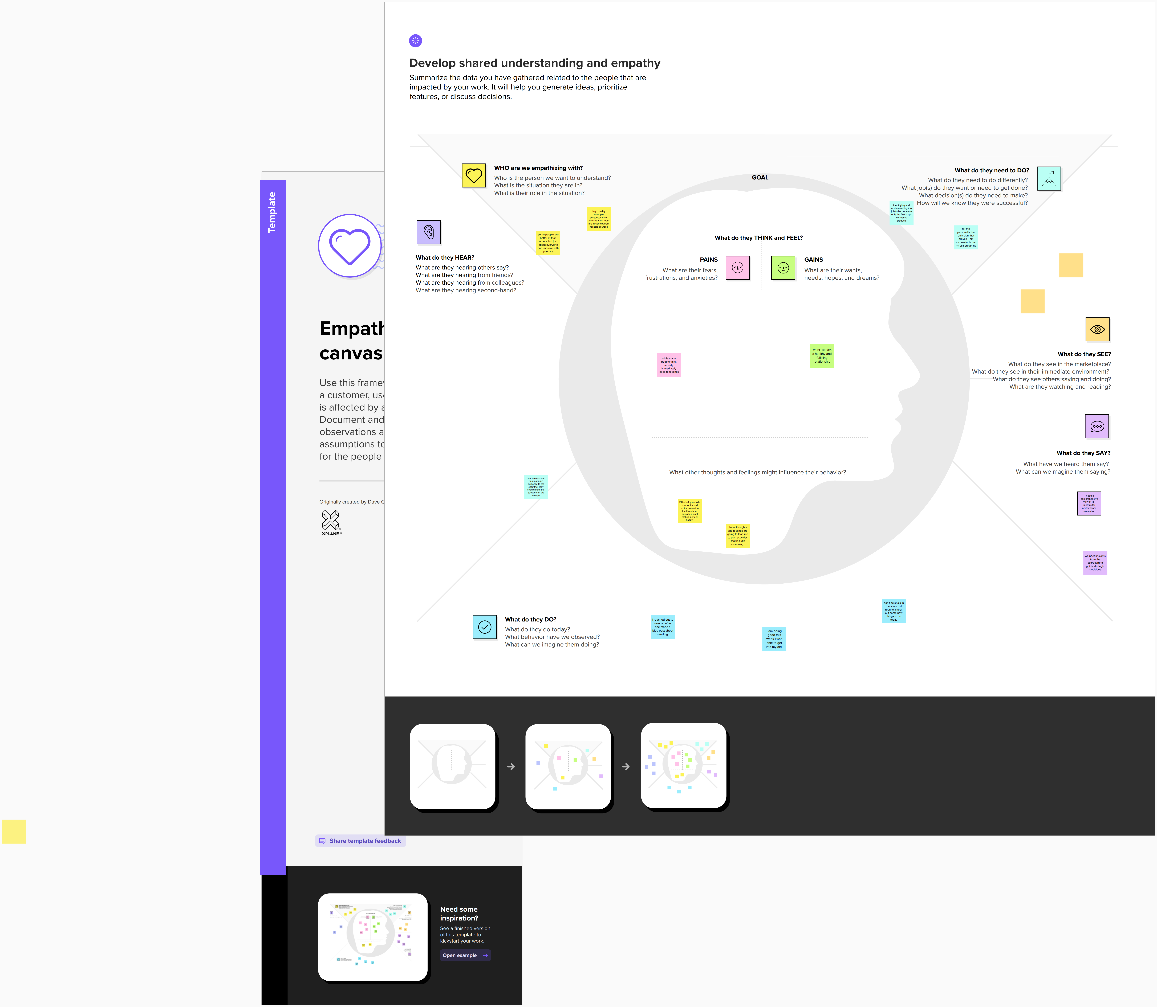

Ideation & Brainstorming Map:



1. Result

Dashboard:

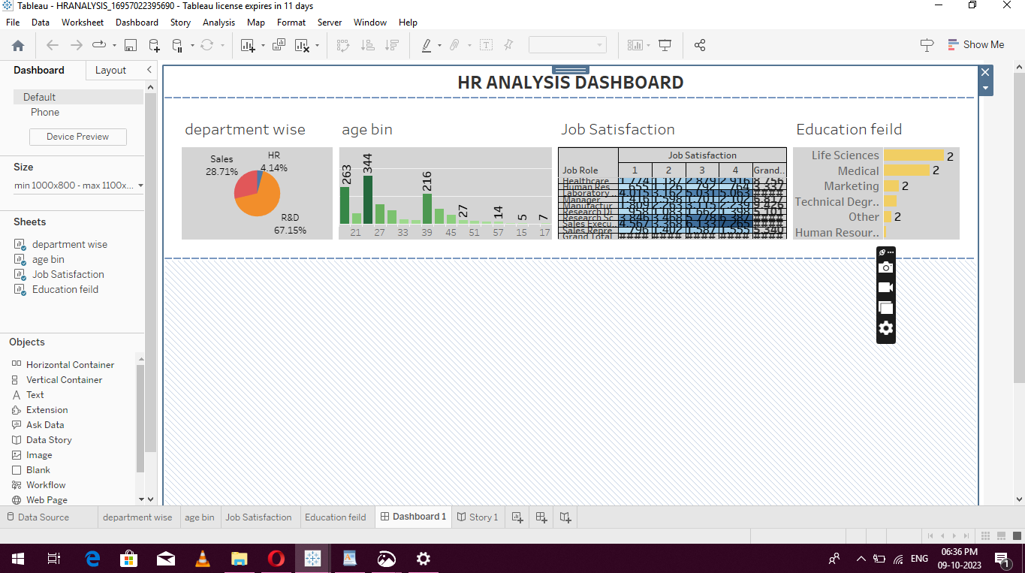

Story:

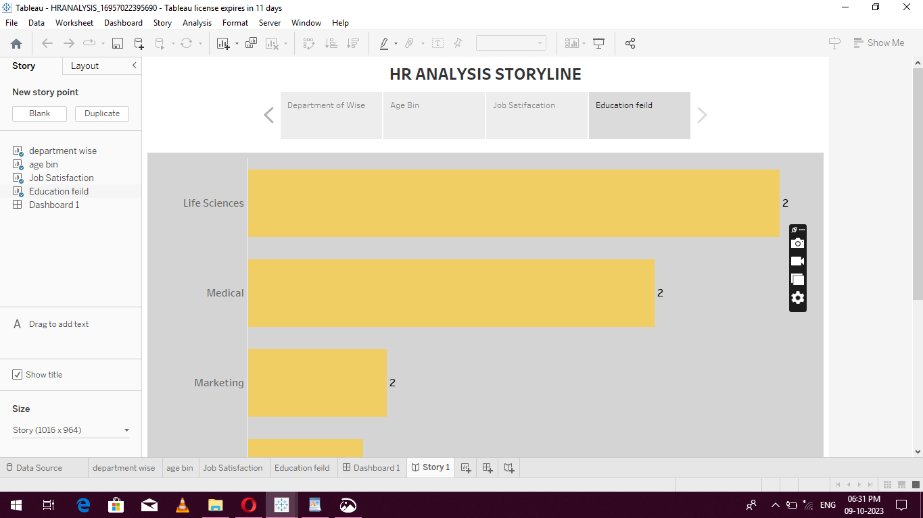

1. Advantages

**Distributed workload.** Successful service delivery can lessen the HR workload, leaving time and energy for other critical tasks. A tiered model allows employees to handle less critical issues through self-service, freeing up specialized HR personnel to work on other tasks.

* **Employee experience.**Millennials and Generation Z have expectations for consumer-grade technology experiences, which tiered HR service delivery platforms can create. Providing this can improve employee experience along multiple stages of the [employee lifecycle](https://www.techtarget.com/searchhrsoftware/definition/employee-life-cycle), including [employee retention](https://www.techtarget.com/searchhrsoftware/definition/employee-retention) and recruitment.
* **Employee insights.** Using an online platform for employee engagement with HR allows companies to monitor employee interactions and behavior and derive analytics based on reporting. Management will have an accurate snapshot of employee satisfaction, productivity and other factors. One example of this is the [use of artificial intelligence to detect employee burnout](https://www.techtarget.com/searchhrsoftware/news/252496509/AI-deployed-as-employee-burnout-detection-tool) by analyzing employee communications. Another example includes [Oracle's skills management tool](https://www.techtarget.com/searchhrsoftware/news/252502960/Oracle-tool-gives-HR-continuous-update-of-employee-skills) that gives HR an idea of the skills employees have.
* **Monitoring.** [Key performance indicators](https://www.techtarget.com/searchbusinessanalytics/definition/key-performance-indicators-KPIs) and metrics allow HR departments to measure how successfully they meet their goals in providing services to employees. Some examples include monitoring the case volume, average resolution time, average response times, adherence to [service level agreements](https://www.techtarget.com/searchitchannel/definition/service-level-agreement) and most viewed knowledge base articles.

**Disadvantages:**

The first common HR problem in companies is a big one: ensuring you adhere to all relevant laws in your operation area. This can be a huge challenge for small HR organizations, especially if no one on the team has experience dealing with local labor laws and regulations.

* Designating a health and safety person or committee at your organization
* Giving them the tools and training needed to study and understand local health and safety laws
* Empowering them with absolute control over health and safety at the organization, including the power to make changes, upgrades, or even shut down operations temporarily if needed

Health and safety should be a top priority for any company. As such, this challenge should be on your shortlist to tackle as soon as possible.

### ****5.Application****

If you work in HR, you have likely read a lot of cover letters. Many HR professionals have had recruitment responsibilities at one time or another.

However, you should be honest with yourself: Do you really appreciate the linguistic and psychological mechanics of writing a winning application letter to complement your resume? It is one thing recognizing a well-crafted cover letter, but when you want to land your next HR role, sitting down and writing one for yourself is another matter entirely. The human resources cover letter gives you the chance to highlight your personality and demonstrate your impact in a piece of free-form writing that is true to who you are.

This guide, alongside our HR-specific cover letter example, will:

Person 1

* Demonstrate the theory behind writing a human-first HR application letter.
* Outline the elements of your cover letter format – the perfect blend for your career.

Person 2

* Delve into the essential psychology of how to weave a memorable HR career story.
* Write an application letter that will impress even the most discerning of HR leaders.

person3

Let us help you confidently express yourself and impress employers with an HR resume that brings your people skills to life. This resume guide, along with the corresponding human resources resume example, will cover the following topics.

**Person 4**

* Some are heavily involved in directing and managing organizational development initiatives, including employee development, succession planning and organizational design.
* Change management can take many forms and HR is often at the core of deciding what might work.

**6.conclusion:**

Before elaborating on how to write the summary, employment history, education and skills sections, one at a time, here is some general advice for ensuring your resume scores high on all counts, and is actually read in the first place.

Whether you're applying to entry-level HR or a more senior role, people are always at the heart of the matter. An HR resume should center around the specific needs of your future employer’s people. You need to understand the challenges that they face, see the business through their eyes and make your own unique contribution to their development and performance. Whether your role is mainly about recruitment, training or more administrative in nature, your success will be measured by the improvements that are made by, or encountered by, those around you.

It is a common misconception that HR is a fluffy, “nice” gig. Of course, there are always different ways to motivate people to achieve set goals, but it is far from possible to always be “nice.” Your HR resume should obviously include a good deal of soft “human” language. But at the end of the day, HR is a business function like any other. Your job is to make a difference to the bottom line, but channelled through the medium of those around you.

**7. Future Scope**

The keywords for a human resources resume will vary drastically depending on the demands of the role. Examining the employer’s career pages and looking at how job descriptions are written will give you a good insight into the organization's HR activities. For an HR professional, this is critical as window to your future role. Analyze the employer’s brand and you will better understand the context of where you might be working and how to present yourself at the interview.